Receiving Letters of Accommodation through the Guardian System
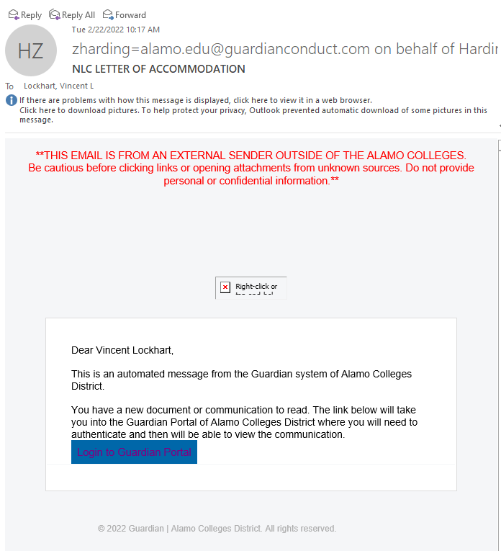
- You will receive an email from a member of the DSS staff via outlook notifying you that you received a Letter of Accommodation. In this email, click the link “Login to Guardian Portal”.

- After opening the link, you will see the Single Sign-On (SSO) for your Alamo account. If you are already logged into your Alamo account on the same browser you may log into Guardian automatically.
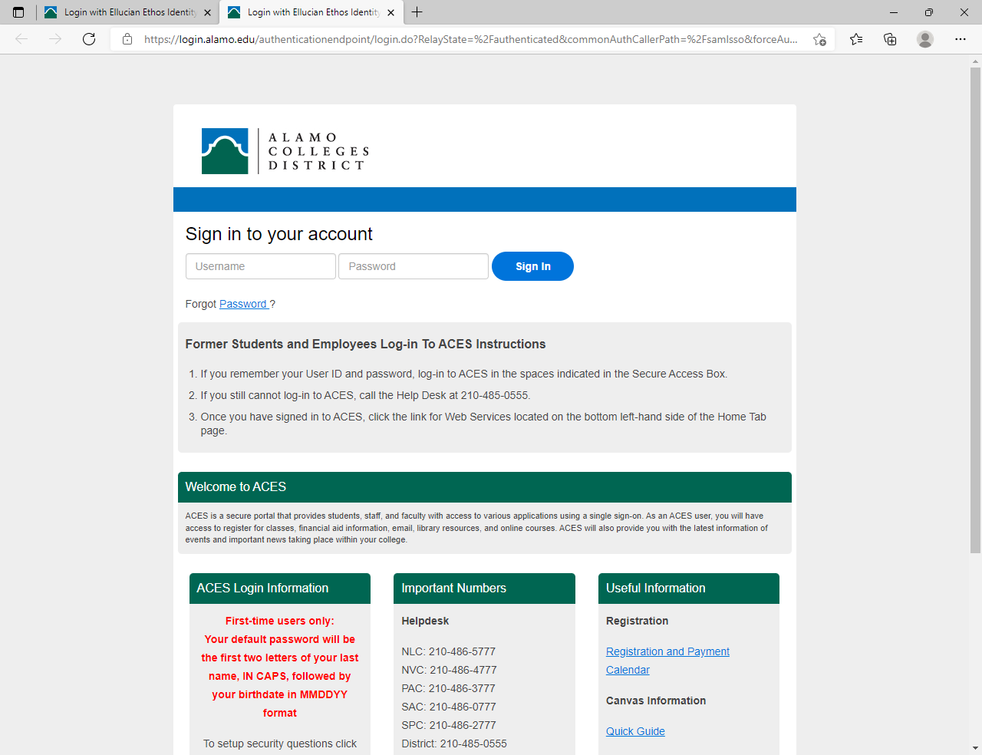

- After logging into Guardian, you will see the form submission screen. This is the screen anyone without a caseload will see. As a faculty member you may not be assigned any cases, instead will only be “associated” with them.
From the Alamo Colleges Forms screen, you will see a Case Association and the Bell Icon with a red circle. If this is your first time opening the letter you may click the Bell Icon to see anything new you have received.
If you have already opened the letter previously and wish to view it again, click on Case Association at the top of the screen.
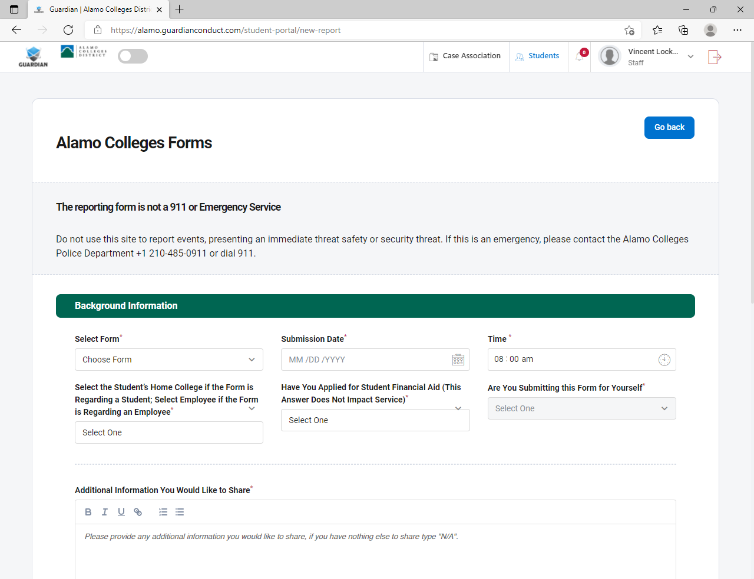

- In the Case Association Screen you will see every “Case” you are associated with. Click on “View Case Details” of the case you wish to view the progress or LOA of. You will not have access to any information you are not supposed to see.
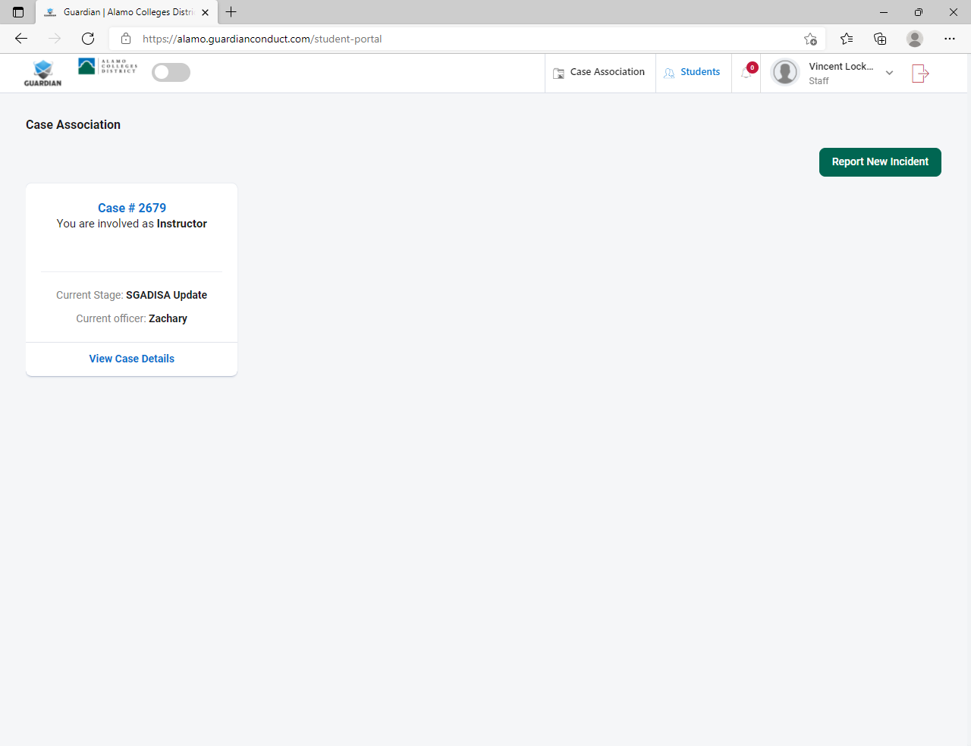

- With the Case open, you can view any correspondence sent to you through Guardian regarding that specific case. To view the LOA click the blue “Click Here to View Email” link. That will open the LOA and at the bottom of the LOA will be a PDF of the letter available to download.

You will be able to access the LOA at any time by logging into your Guardian account by following the link below:

Guardian Case Association page: https://alamo.guardianconduct.com/student-portal
(We recommend bookmarking the link)

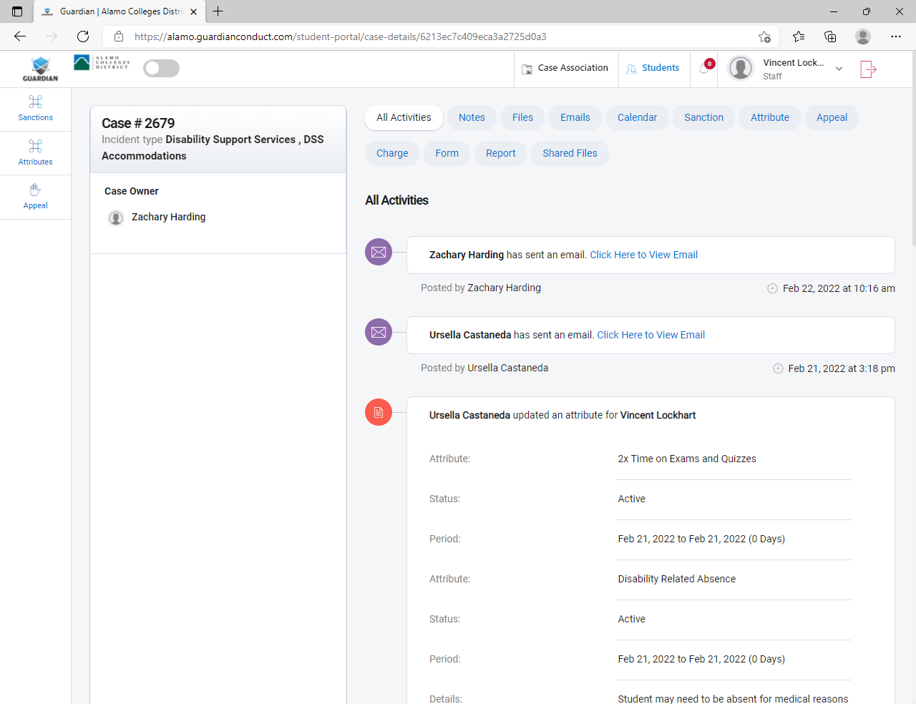
It is more secure to keep the letter within the Guardian system, but you are welcome to download the PDF at your discretion. Keep in mind you need to destroy any downloaded or printed copies at the end of the semester or in the event the student is no longer in your class.

